SCADA (SUPERVISORY CONTROL & DATA ACQUISITION) FOR REMOTE INDUSTRIAL PLANT
ABSTRACT:
The main aim of the project is to process the real time data acquisition under supervisory control for large scale remote industrial environment.
In large industrial establishments many processes go on, therefore it is essential to monitor all the processes and control the factors affecting them. Adapting a technology like SCADA (Supervisory Control and Data Acquisition) one can achieve the above mentioned objective effectively, and thus saving a lot of manpower.
For achieving this real-time scenario, a temperature logging system for a remote plant operation is taken. Here temperature sensors are duly interfaced to the PIC microcontroller. Data collected from the temperature sensors are constantly sent to the microcontroller which is in turn connected to a PC. At the front end, “DAQ System” (software) is loaded on the computer which takes these values and displays them on its front panel, and also logs them in the database. One can set parameters like set point, low limit and high limit on the computer screen. When the temperature of a sensor goes beyond set point the microcontroller sends a command to the corresponding relay. The heaters (shown as lamps) connected through relay contacts (corresponding to their sensors) are turned OFF (or ON in vice versa). High limit and low limit features are available for generating an AV alarm on the PC in the event of system failure.
Hence, processes at hazardous areas can be controlled with more accuracy and better safety using SCADA. Adapting such a technology will save both money and time.
NOTE: This project works only on Windows XP operating system. The computer must have a serial port (RS232) in it.

BLOCK DIAGRAM
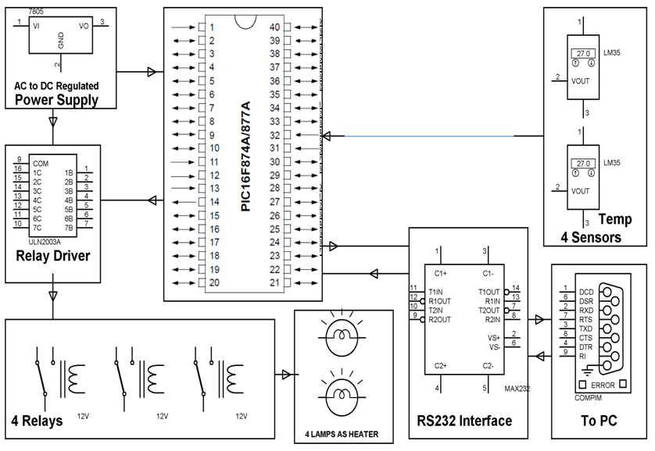
HARDWARE REQUIREMENTS:
PIC series Microcontroller, ADC, Temperature sensors, Max232, Relay Driver IC, Crystal, Resistors, Capacitors, Diodes, Transformer, Voltage Regulator, Relays , Transistors, DB9 connector, Loads.

SOFTWARE REQUIREMENTS:
HI-TECH PICC Tool suite
Language: Embedded C or Assembly.

